R.PRANUSHA

192111023

CSA1557-CLOUD COMPUTING

Exp 14) Create a Snapshot of a VM and Test it by loading the Previous Version/Cloned VM

Step 1: shut down the ubuntu server

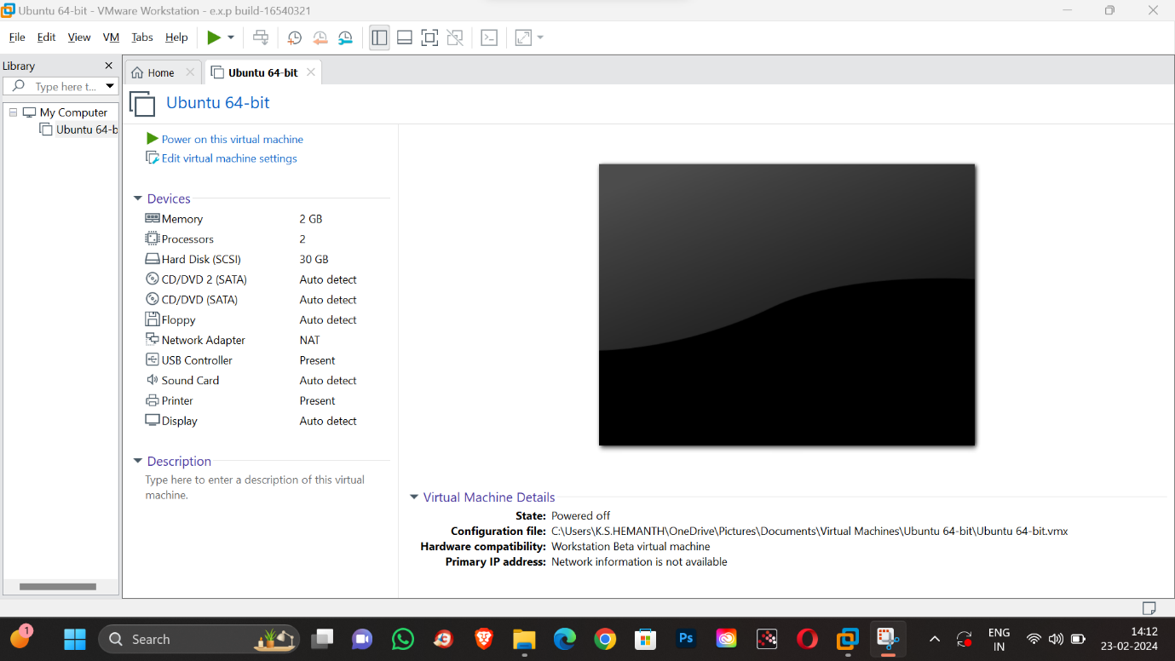

Step 2: Take a snapshot and save it as snapshot 1.

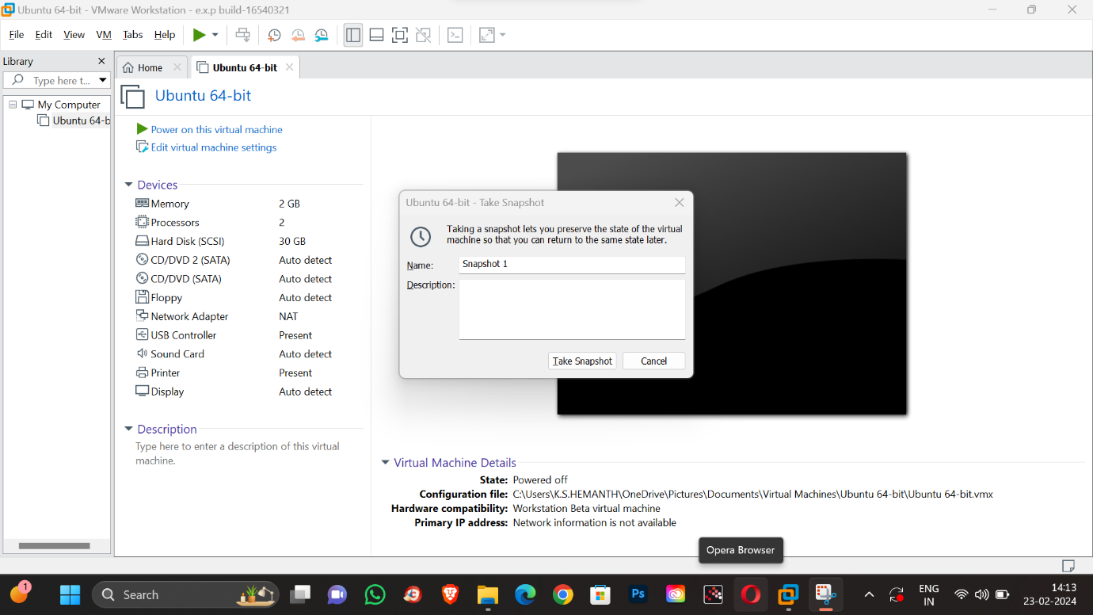

Step 3: change the RAM memory to 1 GB

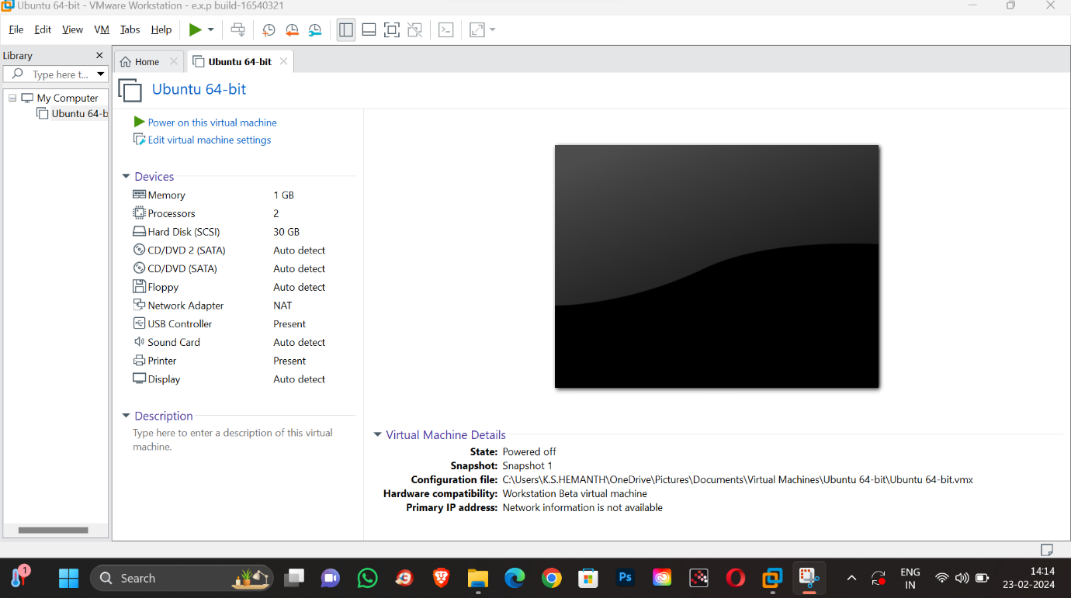

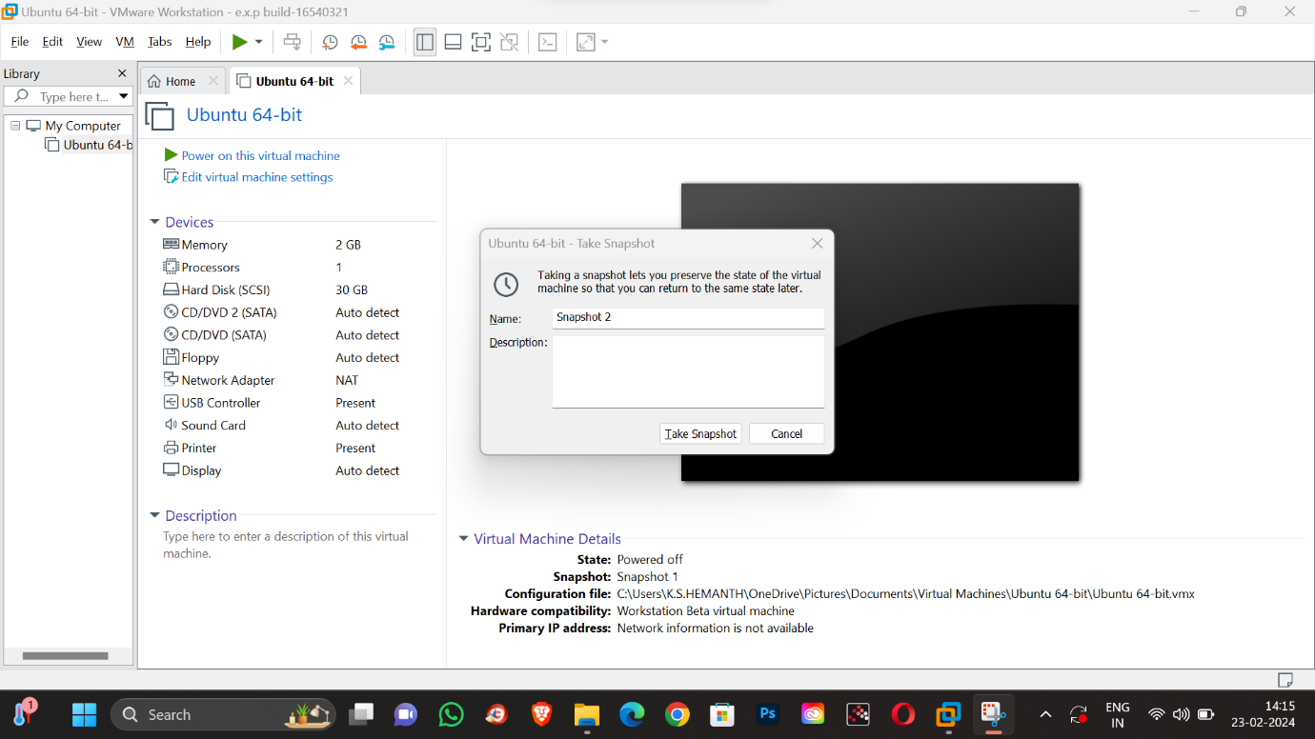

Step 4: change the processor core to core 1



Step 5: Take a snapshot ans save it as snapshot 2

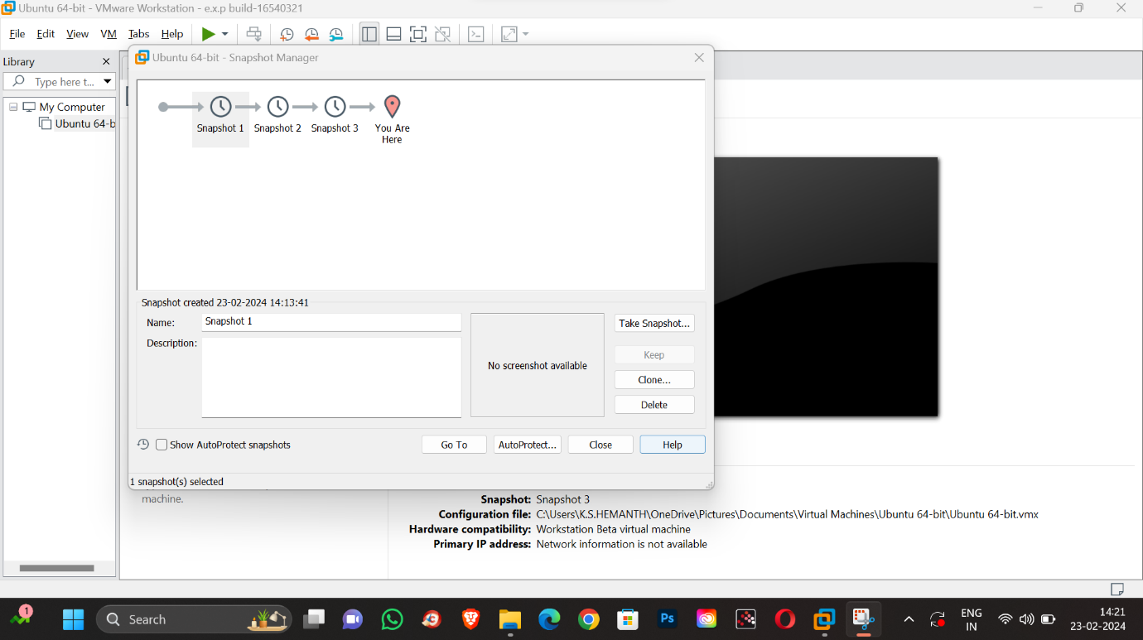

Step 6: Add the hard disk 15GB .

Step 7: take a snapshot and save it as snapshot 3.

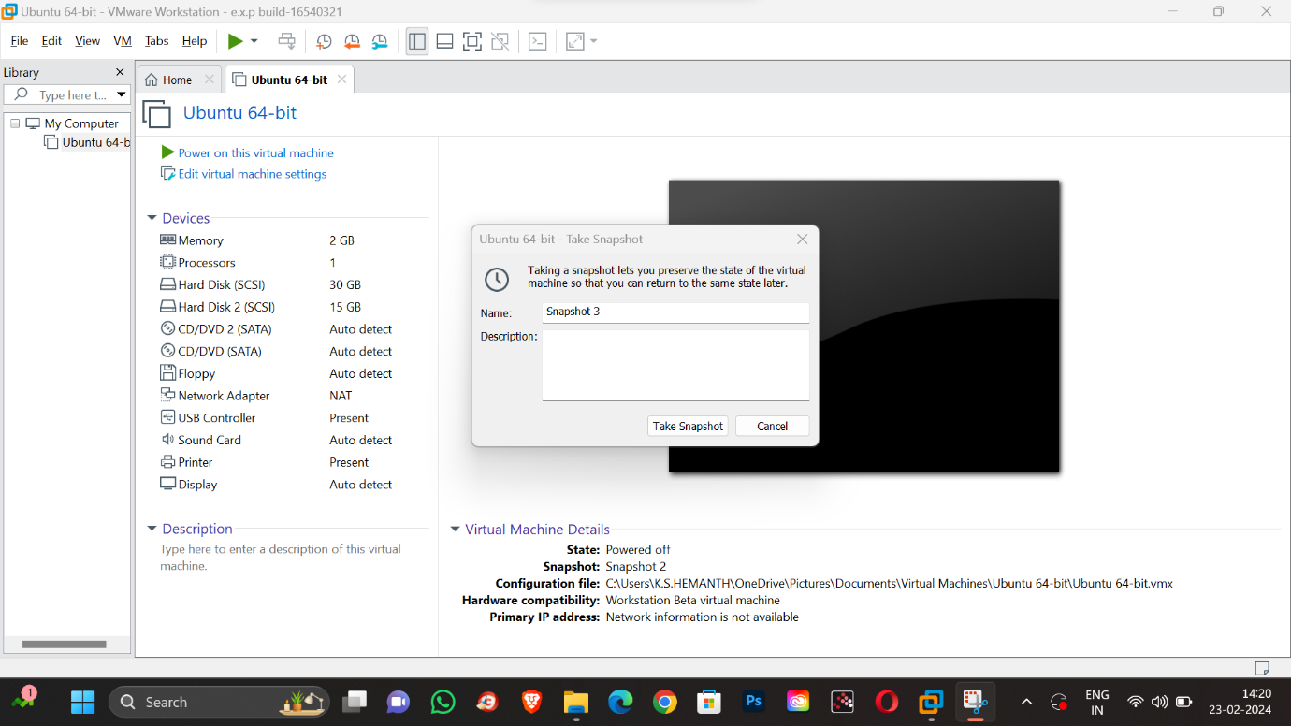

Step 8: open snapshot manager

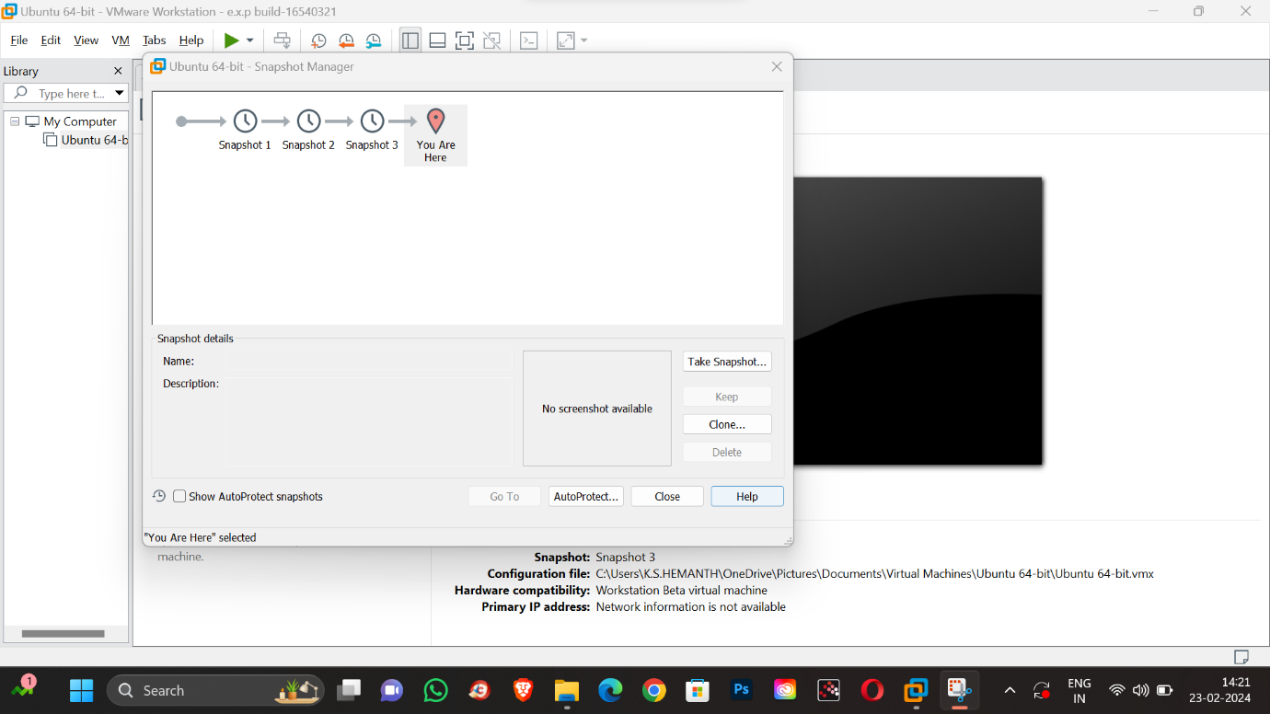

Step 9: choose snapshot 1 ,and switch to snapshot 1



Step 10: switch to snapshot 1 by clicking “go to”.

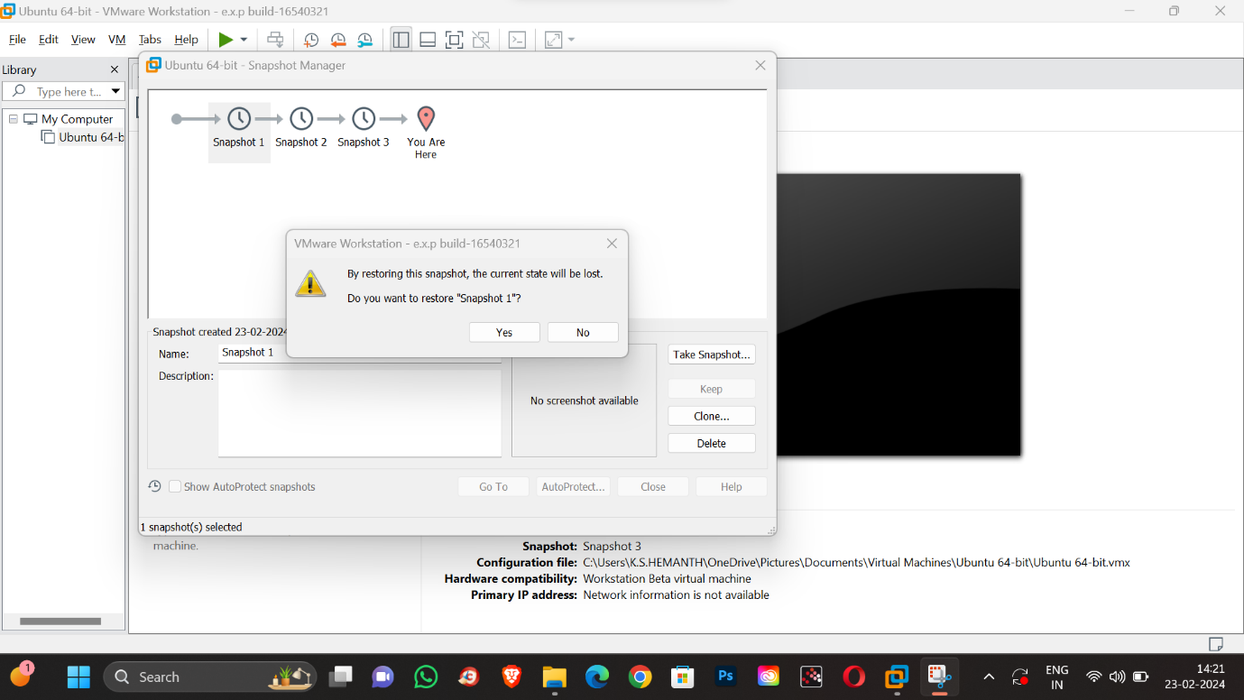

Step 11: click on “yes”

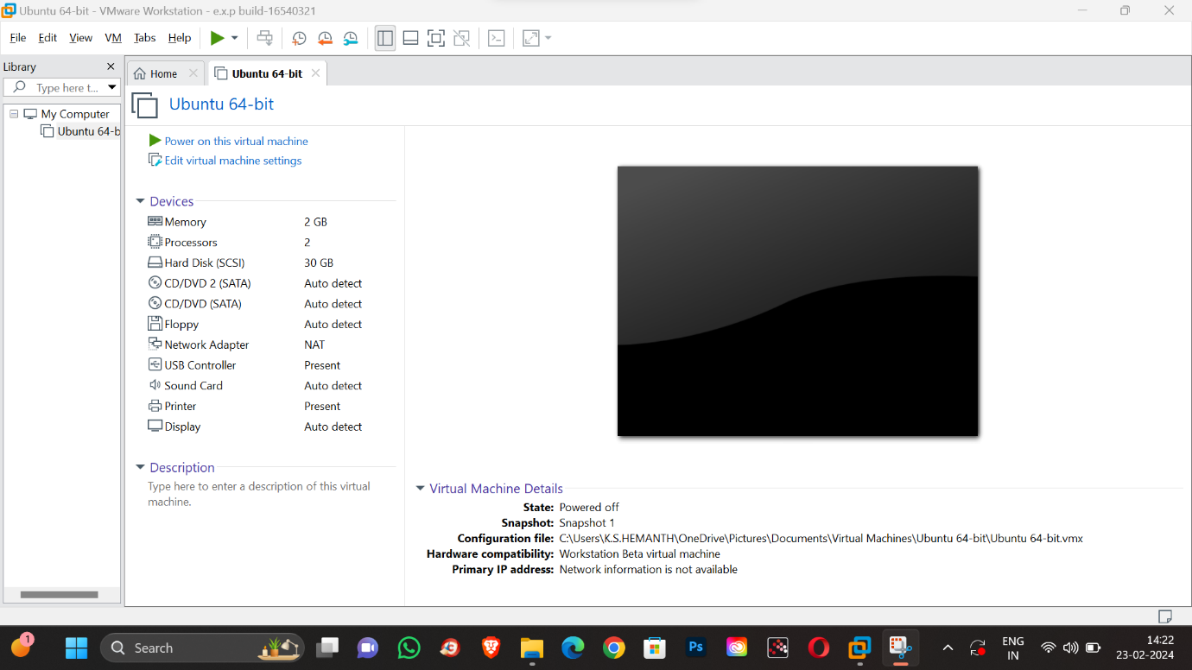

Step 12: the snapshot 1 has been retrieved .But the other snaps has been deleted .